**TRACERX**

Team Lead – Divyanshu Shrivastava

**Team –**

|  |  |  |
| --- | --- | --- |
| 1 | Divyanshu Shrivastava | 187909 |
| 2 | Ekta Singh Parmar | 187910 |
| 3 | Ravi Mandoriya | 187928 |
| 4 | Sonali Mandloi | 187936 |
| 5 | Sumit Sisodiya | 187938 |
| 6 | Tanvi Chalisgaonkar | 187943 |
| 7 | Vandita Patel | 187944 |

**Contents –**

1. trial1.c
   1. trial1 1
   2. trial1 2
   3. trial1 1 with error
2. test13.c
   1. test13 1
   2. test13 2
3. pals1-cil.c
   1. pals1-cil.c 1
   2. pals1-cil.c 2

**trial1.c 1**

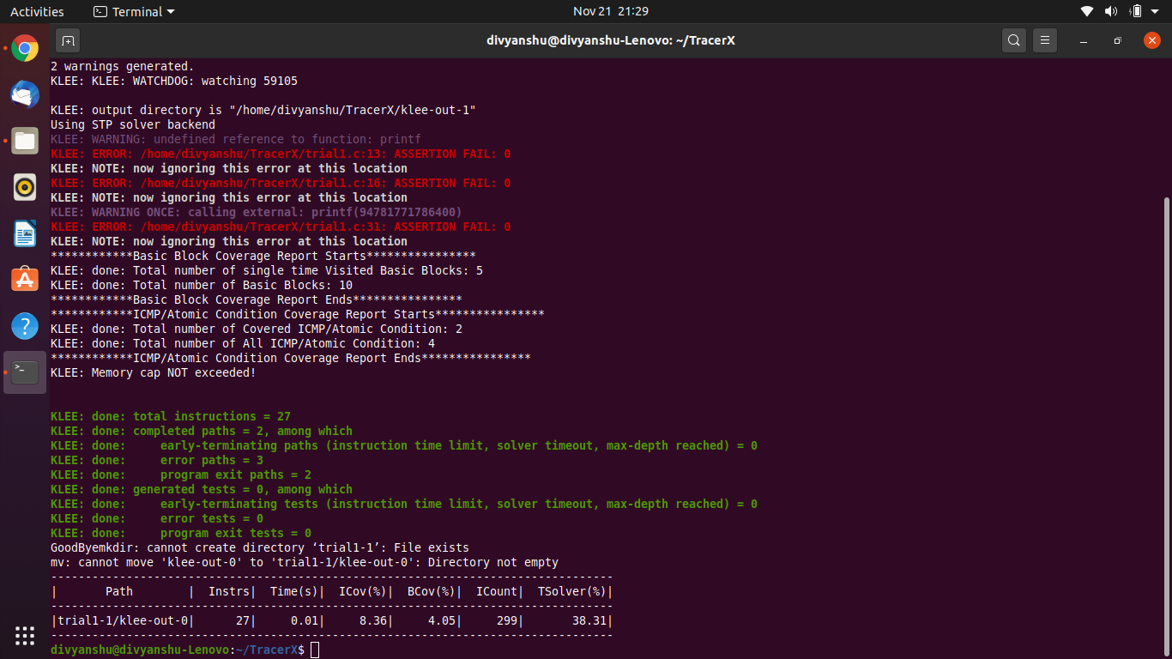

**trial1.c 2**

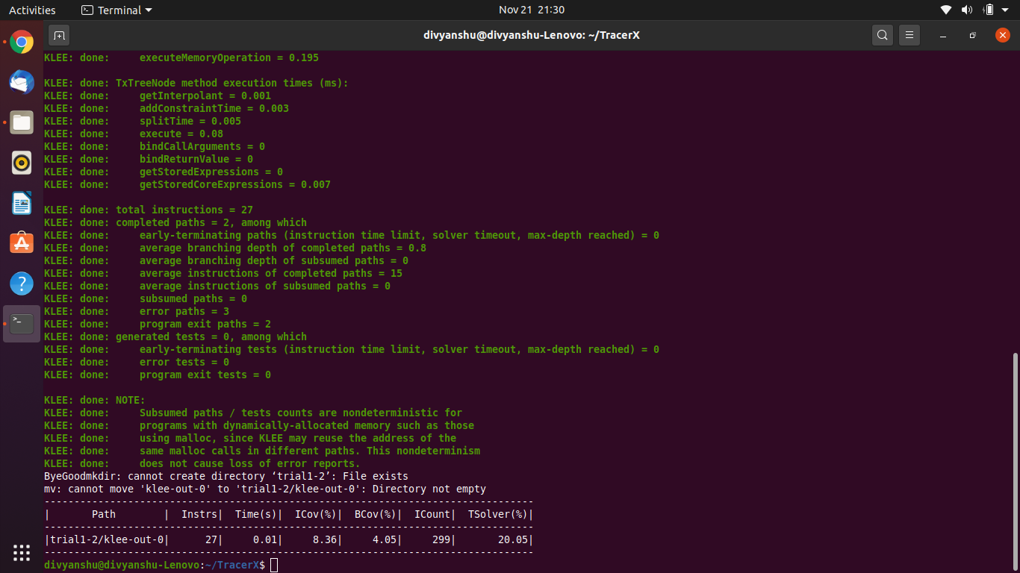

**trial1.c 1 with error**

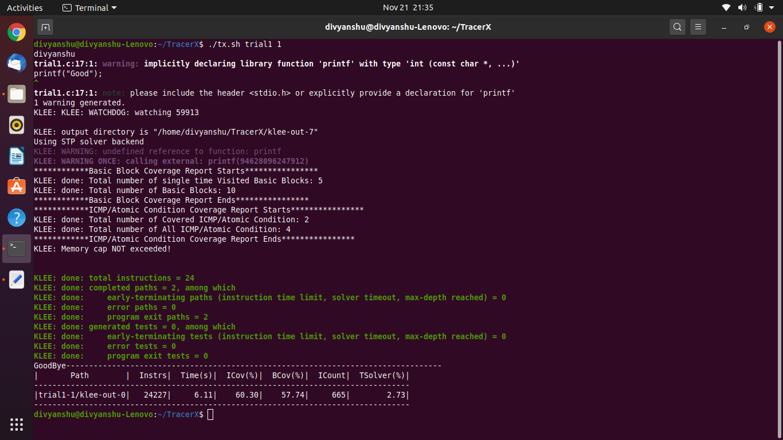

**test13.c 1**

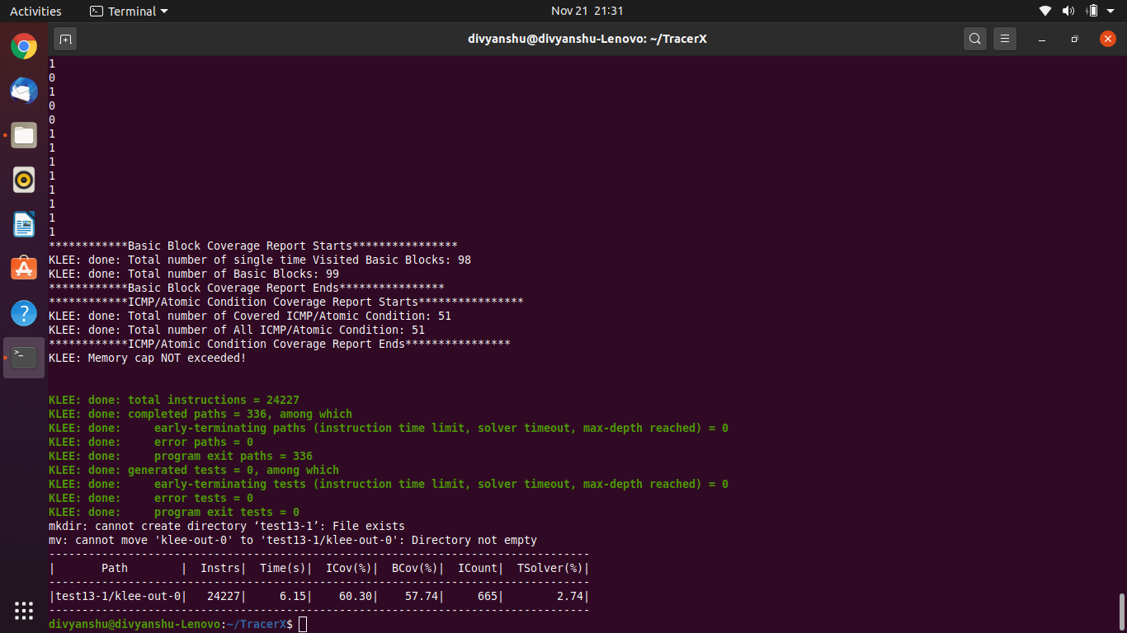

**test13.c 2**

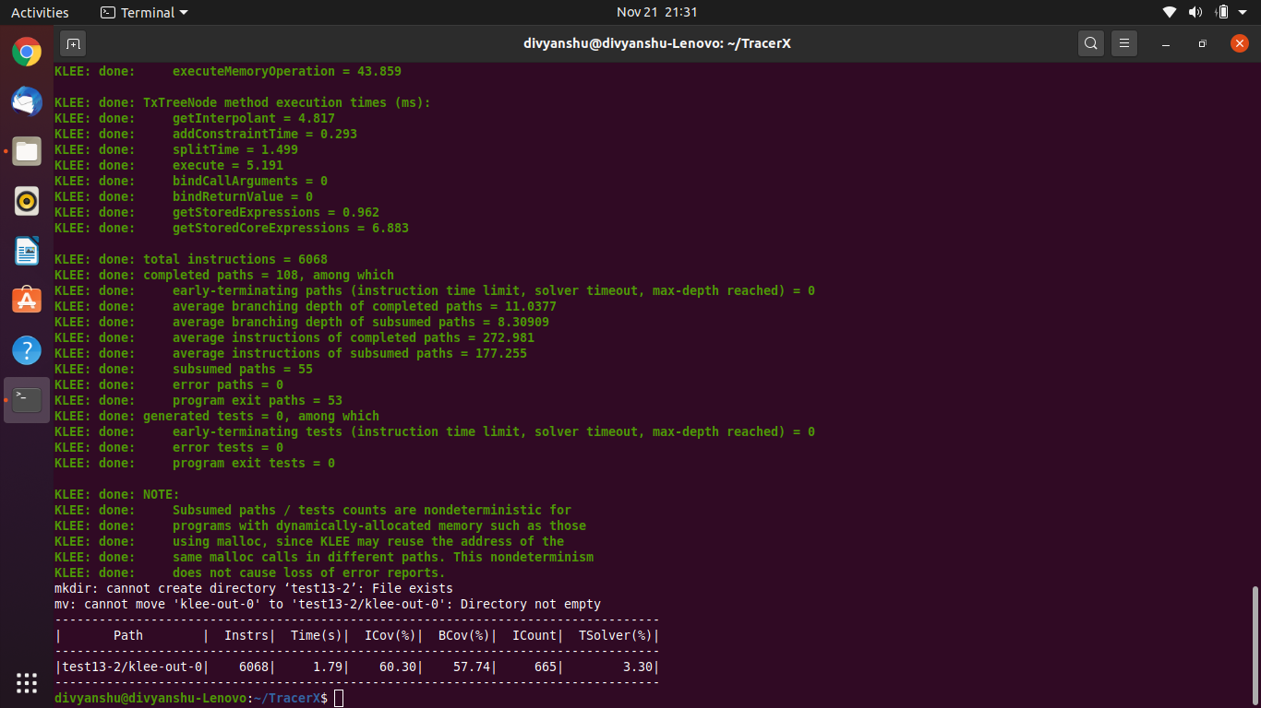

**pals1-cil.c 1**

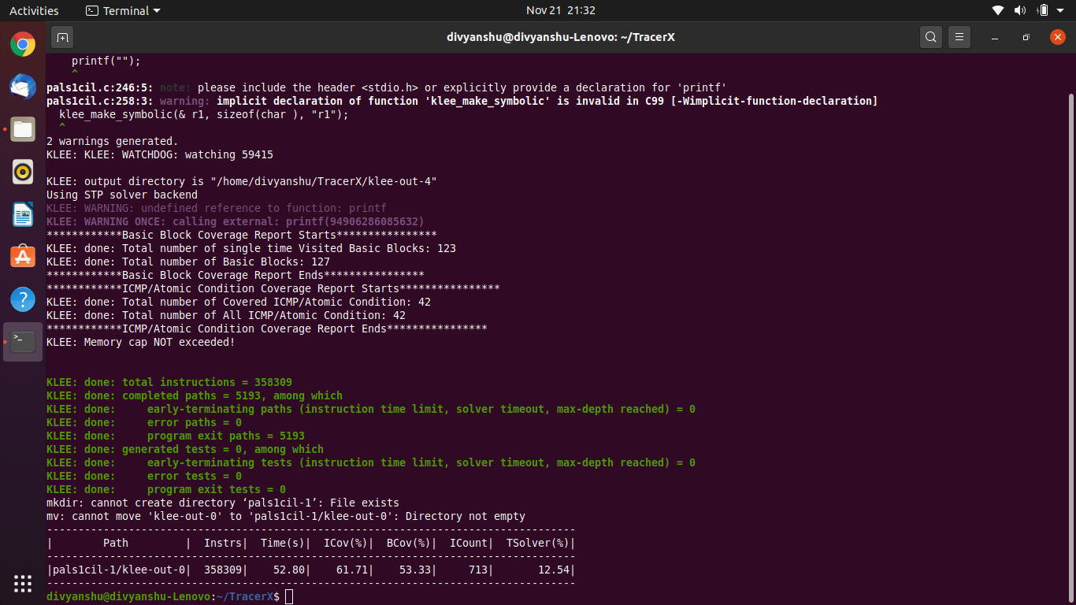

**pals1-cil.c 2**

